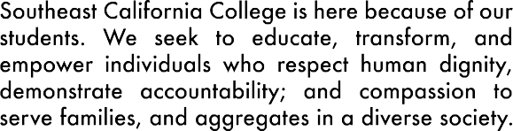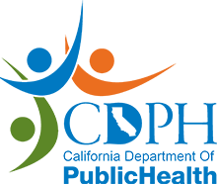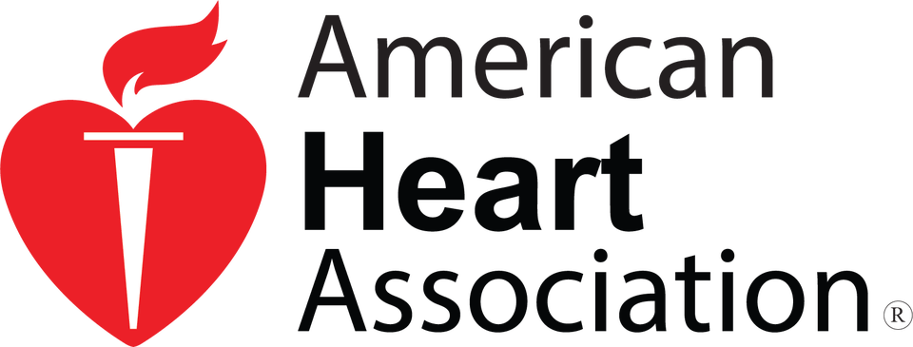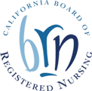

# 22S5aEn. BAeirrpnoarrtdiDnroiv, CeASu9i2t4e01850

[www.southeastcacollege.com](http://www.southeastcacollege.com/)

**Vocational Nursing Program**

The Vocational Nursing program is designed to provide students with the knowledge and skills necessary for an entry-level vocational nurses position in a medical office, clinic, HMO, PPO, acute care, hospital, long term care facility or other health care settings. It develops knowledge and skills to provide direct care to the patients/clients/residents under the supervision of a physician, dentist, or registered nurse (RN) in a variety of health care settings, such as hospitals, long term convalescent care facilities, and home health care agencies.

**ENROLLMENT CLASS I STARTS**

**ONGOING June 2023**

**FULL-TIME/PART-TIME VN CLASSES**

**57 WEEKS 13 MONTHS 1,555 HOURS 4 QUARTERS**

**CERTIFICATIONS**

**IV Therapy & Blood Withdrawal**

**4 DAYS 36 HOUR CLASS**

**Gives 16 units of CEUs to LVNs**

**CPR/BLS with AED**

**6 HR CLASS 4 HOUR CLASS**

INITIAL $80 RENEWAL $60

**NCLEX REVIEW CLASSES**

**For RN and LVN**

**REGISTRATION ONGOING**

**ONGOING REGISTRATION**

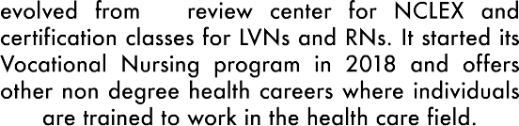

**Clinical Medical**

**Assistant (CMA)**

This program is designed to prepare students with knowledge and skills to work in Medical offices and clinics. Students learn EKG, blood draw, insurance billing, advanced nursing skills, vital signs and assist doctors with diagnostic examinations and physical assessments.

**28** **WEEKS**

**910**

**HOURS**

**Home Health Aide (HHA)**

You will learn the skills necessary to work in patients’ homes to provide client personal care.

**2.5 WEEKS 40 HOURS**

**INCLUDES: Books & Uniform**

**Patient Care**

**Technician/Assistant (PCT/A)**

This is beginning career training for basic and advanced nursing skills including assisting with sterile procedures, EKG placement and monitoring, and Blood withdrawal. Graduates are called technicians after passing the national certification examinations the National Health Career Association.

**10 WEEKS 160 HOURS**

**Wound Care Management**

This program prepares graduates to be a Certified Wound Care Nurse. This can be offered to an RN or LVN. It is a 184 hr program that includes 64 hr theory and clinical plus 120 hr externship with a certified wound care nurse. Graduates will take the National Wound Care Certification examination to become certified.

**8 WEEKS**

**184 HOURS**